**INTI International College Penang School of Computing**

**3+0 Bachelor of Science (Hons) in Computer Science, in collaboration with Coventry University, UK 3+0 Bachelor of Science (Hons) in Computing, in collaboration with Coventry University, UK**

# Coursework cover sheet

**Section A - To be completed by the student.**

|  |  |
| --- | --- |
| Full Name:  **LIM WENG HONG** | |
| CU Student ID Number:  **14196232** | |
| Semester:  **1** | |
| Session:  **April 2023** | |
| Lecturer:  **Puteri Nursyawati Azzuri (puteri.azzuri@newinti.edu.my)** | |
| Module Code and Title:  **4067CEM Software Design** | |
| Assignment No. / Title:  **Continuous Assessment** | % of Module Mark:  **50** |
| Hand out Date:  **12 May 2023** | Due Date:  **Task 1: 02 June 2023, by 11.59pm.**  **Task 2: 07 July 2023, by 11.59pm**  **Task 3: 23 June 2023, by 11.59pm.**  **Task 4: 23 June 2023, by 11.59pm.**  **Task 5: 23 June 2023, by 11.59pm.** |
| Penalties: No late work will be accepted. If you are unable to submit coursework on time due  to extenuating circumstances, you may be eligible for an extension. Please consult the lecturer. | |
| Declaration: I/we the undersigned confirm that I/we have read and agree to abide by the University regulations on plagiarism and cheating and Faculty coursework policies and procedures. I/we confirm that this piece of work is my/our own. I/we consent to the appropriate storage of our work for plagiarism checking.    Signature(s): | |

# Section B - To be completed by the module leader

|  |  |  |
| --- | --- | --- |
| Intended learning outcomes assessed by this work:   1. Understand and apply appropriate concepts, tools, and techniques to each stage of the software development. 2. Understand and apply design patterns to software components in developing new software. 3. Demonstrate an understanding of project planning and working to agreed deadlines, along with professional, interpersonal skills and effective communication required for software production.   5. Demonstrate an awareness of, and ability to apply, social, professional, legal, and ethical standards as documented in relevant laws and professional codes of conduct such as that of  the Malaysian National Computer Confederation. | | |
| Marking scheme | Max | Mark |
| 1. User Story Mapping | 20 |  |
| 2. Setting up a GitHub |  |
| Repository | 10 |
| 3. Creating a Class diagram and |  |
| design pattern selection | 30 |
| 4. Creating a Prototype User |  |
| Interface and Usability Testing | 20 |
| 5. Discuss the ethical issue |  |
| related to the software | 20 |
| Total | 100 |  |

**The 4067CEM assessment should be completed as a full individual work over the course of the module. The assessment output are only judged at the end of the module and not by the expectations during that week. The assessment should be undertaken individually. All submissions will be checked against each other and the internet for possible plagiarism.**

Activities – These activities consist of **50%** of your coursework marks. It will be run throughout the semester and there will be a final submission at the end of the semester. These activities consist of activities that will be done in a software design phase.

# System

Student Business System for College.

# Task 1 – User Story Mapping (20 marks)

The first thing that you need to do is ask the user what they wished for in a system. The user here can be your friends as the system is related to them. Get at least 10 real users to get their feedback. Document their feedback. Use software like Trello to complete this activity.

Output – All the user stories, and backlog with goals, activities, and tasks. In Word format, uploaded it to GitHub.

Due – Week 9 of the semester. 02 June 2023, by 11.59 pm.

# Task 2 – Setting up a GitHub Repository (10 marks)

This is where the output of the tasks will be stored, Make sure you register an account, create a repository and your files are uploaded here and it is in an organized manner and can be easily found.

Output – GitHub Repository with Task 1, Task 3, Task 4 and Task 5 documents. Take note the date of the files will be shown so you must follow the due date of each task.

Due – It will be accessed on Week 14 of the semester. 07 July 2023, by 11.59 pm

# Task 3 – Creating a Class diagram and design pattern selection (30 marks)

Create a simple Class diagram which should consists of the Classes that might be used to represent the system and the association between them. You don’t have to declare the attributes and operations for this activity. You do have to explain the class responsibility of each class declared. You can use software like StarUML to complete this activity.

Output – A class diagram containing classes and associations. In Word format, uploaded it to GitHub.

Consider the problem and select a suitable design pattern that can be implemented on the problem. Give justification on why the design pattern was chosen. Draw the UML diagram representing your class diagram as a design pattern UML. Include all the abstract class/interface, concrete class, and inheritance (if any) used to represent the problem.

Output – UML diagram representing the design pattern. In Word format, uploaded it to GitHub. Due – Week 12 of the semester. 23 June 2023, by 11.59 pm.

# Task 4 – Creating a Prototype User Interface and Usability Testing (20 marks)

Create a Prototype User Interface (hand drawn/digital) of TWO (2) important functions of the proposed system. Come up with usability testing questions. You don’t have to carry out the test, just prepare the questions. You should indicate what you are testing for in the Usability Testing.

Output – A Prototype and Usability Testing Questions. In Word format, uploaded it to GitHub. Due – Week 12 of the semester. 23 June 2023, by 11.59 pm.

# Task 5 – Discuss the ethical issue related to the software (20 marks)

Discuss and do a critical analysis of your software in these areas, privacy concerns, intellectual property rights, and effects on society.

Output – A report in Word format, uploaded to GitHub.

Due – Week 12 of the semester. 23 June 2023, by 11.59 pm.

# Submission

All tasks needed to be documented in Word format and submitted for SafeAssign checking (Links will be provided before the due date).

Upload the document and the SafeAssign report to your GitHub repository by each task due date. Due – It will be accessed on Week 14 of the semester. 07 July 2023, by 11.59 pm

# Marking Rubric for Continuous Assessment

|  |  |  |  |  |  |
| --- | --- | --- | --- | --- | --- |
|  | **Marks Below 40%** | **Marks in the range 40 – 49%** | **Marks in the range 50 – 59%** | **Marks in the range 60 – 69%** | **Marks 70% and above** |
| **User Story** | User Story Mapping | User Story Mapping | User Story Mapping | User Story Mapping | User Story Mapping done and does capture most important activities of the system. The breakdown of the user story mapping is excellent and uses software that can assist that process (For example Trello compared to Ms.  Word). |
| **Mapping** | not done or User | done at a minimum | done and does | done and does |
| **(20 marks)** | Story copied/does  not match the exact | level and does not  capture the | capture several  important activities of | capture several  important activities of |
|  | system. | important activities of | the system. The | the system. The |
|  |  | the system. | breakdown of the | breakdown of the user |
|  |  |  | user story mapping | story mapping is good |
|  |  |  | can be improved. | and uses software that |
|  |  |  |  | can assist that |
|  |  |  |  | process (For example |
|  |  |  |  | Trello compared to |
|  |  |  |  | Ms. Word). |
| **Setting up a** | GitHub repository | GitHub repository | GitHub repository | GitHub repository exist | GitHub repository |
| **GitHub** | does not exist or | exist and some of | exist and most of the | and all of the required | exist and all of the |
| **Repository** | cannot be accessed | the required files are | required files are | files are available at | required files are |
| **(10 marks)** | or the required files  are not available at | not available at the  time of access. | available at the time  of access. However | the time of access.  However the dates for | available at the time  of access. The dates |
|  | the time of access. |  | the dates does not | some files does not | on the files follows |
|  |  |  | follow the required | follow the required | the required |
|  |  |  | deadline. | deadline. | deadline. |
| **Creating a** | The Class diagram | The Class diagram | The Class diagram | The Class diagram | The Class diagram |
| **Class diagram** | does not represent | and design pattern | and design pattern | and design pattern | and design pattern |
| **and design pattern selection (30 marks)** | the required solution (contains generic or non- related classes  such as admin), the design pattern | represent the required solution but in a very general and incomplete way.  Required classes in | represent the required solution in a partial way. A few  required classes in the design are not | represent the required solution in a satisfactory way. Most  required classes are declared. | represent the required solution in an excellent way. All  required classes are declared. |
|  | suggested is not | the design are not | declared. |  |  |
|  | suitable for the given | declared. |  |  |  |
|  | problem. |  |  |  |  |

|  |  |  |  |  |  |
| --- | --- | --- | --- | --- | --- |
| **Creating a Prototype User Interface and Usability Testing**  **(20 marks)** | No prototype were available or the measurement for the usability testing is not clear. | The prototype cover minimalist and trivial design (such as login) and the measurements for the usability testing are not clear. | The prototype cover adequate design and several measurements for the usability testing are not clear. | The prototype cover good design and most measurements for the usability testing are clear. | The prototype cover excellent design and all measurements for the usability testing are clear. |
| **Discuss the ethical issue related to the software**  **(20 marks)** | There is no discussion on the ethical issue or only the theories are pasted back for this component. | There is an attempt to discuss on the ethical issue but no critical  analysis was done | There is an attempt to discuss on the ethical issue with some critical analysis was done | There is an attempt to discuss on the ethical issue with good critical analysis. | There is an attempt to discuss on the ethical issue with excellent critical analysis. |

**TASK 1 – USER STORY MAPPING (20 MARKS)**

**Introduction**

In agile development, user story is a main requirement. User story mapping comprises of short sequences writing in easily understandable human language stating how the to-be system will function **(Tsilionis et al., 2021)**. The development of a user story mapping is as follows: Collecting data on features desired by its users through survey approaches like interviews and survey forms, responses collected are converted into a user story which consists of brief descriptions for each goal, finalized user story is then utilized by developers to map out a diagram.

**(Development stages of user story mapping)**

The same approach also applies to the development of a system business system for a college. The developing stages are as follows:

**Data Collection (Survey Questions):**

The survey was conducted on campus grounds where the interviewer approached random students, asking these two questions:

* “What features do you want in a student business system for a college that you think would be tremendously helpful (i.e.: IICP Digital Hub)?”
* “How would this feature benefit you as a student/potential student in this specific institution?”

**Collected Data:**

All feedbacks on what features should be made available to the system were provided by student(s) from INTI International College Penang. Their suggestions are as follows:

1. “**Course materials**. I want to be able to access materials like past-year-papers and course structure.”
2. “**Online resources**. While I’m not on campus, I want to be able to access academic materials like reference books and journals digitally.
3. “**Semester calendar.** I would like to be able to tell which holidays are being observed by the campus.”
4. “**Online support**. This will aid students in payment processing or campus account issues while off-campus.”
5. “**Upcoming event(s) information**. If I see something that interests me, I might be inclined to participate in it to expand my social network.
6. “**Campus navigation**. Having a virtual tour of the available facilities allows me to easily get to where I need to go.”
7. “**Campus news and announcements**. This would be helpful in special circumstances where students are uncertain whether classes are still being conducted on campus.”
8. “**Online enrollment**. I want the option to enroll into programs through the internet rather than having to do so physically.”
9. “**Exam timetable**. Being able to see the exam schedule allows me to plan my study session accordingly.”
10. “**Student support resources**.Some people require academic, counselling, and transportation assistance during their journey in college. Being able to request for support online makes it much more convenient.”

**User Story:**

A user story is created from the feedbacks received from several students in the following format:

*[As a <Type of user>, I want <Task> so that <Goal>]*

1. As a student, I want to access course materials like past-year-papers and course structure so that I can prepare for exams.
2. As a student, I want to be able to access academic materials like reference books and journals while away from campus so that I can complete my research for assignments.
3. As a student, I want to be able to check semester calendar so that I know what holidays are observed by the college.
4. As a student, I want to be able to receive online support for payment or campus account issues so that I can ensure my studies remain uninterrupted.
5. As a student, I want an announcement for upcoming events so that I can expand my social network.
6. As a student, I want to be able to tour the campus virtually so that I can familiarize myself with the facilities which are made available to me.
7. As a student, I want the system to publish news and announcements during special circumstances like water supply cuts or haze, informing students whether classes are cancelled or moved to a different venue.
8. As a student, I want to be able to enroll into courses online so that I can save time from having to travel to campus
9. As a student, I want to be able to find out my exam timetable from the site so that I can manage my study time accordingly.
10. As a student, I want to be able to access student support resources and apply for services like counselling (physical/virtual) or free transportation to campus so that I get the help I need to stay focus on my studies.

**User Story Mapping:**

Full resolution image available at: <https://shorturl.at/ekoFU>

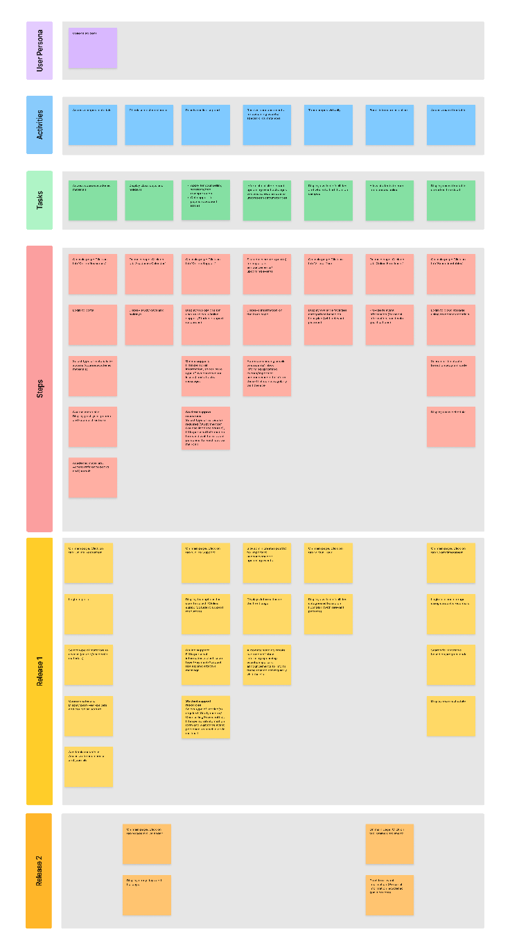

|  |
| --- |
|  |
|  |
|  |
|  |
|  |
|  |
|  |

|  |
| --- |
|  |

**REFERENCE(S):**

Tsilionis, K. *et al.* (2021) ‘Conceptual modeling versus user story mapping: Which is the best approach to agile requirements

engineering?’, *Research Challenges in Information Science*, pp. 356–357. doi:10.1007/978-3-030-75018-3_24.